CptS 427 – Project Report
Zachary Mullin

GitHub Link:
https://github.com/Zelefant/CPTS427-Project

Introduction
Public wireless environments such as cafes, libraries, airports, and university common areas
are widely used but often poorly understood from a security and privacy perspective. These spaces commonly deploy multiple wireless technologies and protocols that introduce hidden risks to users, including passive data leakage, misconfigured devices, insecure encryption, and false assumptions about safety.
The motivation of this project is to analyze real-world public wireless spaces to identify security and privacy weaknesses stemming from device configurations, protocol usage, and user misconceptions. By inventorying deployed wireless technologies, capturing and analyzing traffic, and evaluating device configurations where feasible, this project aims to surface concrete risks and provide practical hardening recommendations. The project emphasizes understanding how multiple wireless protocols interact in shared university environments (e.g. libraries, the CUB) and how these interactions can undermine user privacy and security.

Locations Analyzed
- Owen Science and Engineering Library
  - 2nd floor, west side of the building
- Holland Library
  - 2nd floor, east side of the building
- Terrell Library
  - 2nd floor, near windows overlooking football fields
- Compton Union Building (CUB)
  - Outside the Bookie, main floor
- The SPARK Academic Innovation Hub
  - 3rd floor, southwest corner of building
- Chinook Student Center
  - Bottom floor near E-Sports Lounge

Tooling
- OS: Linux Mint
- Tools used:
  - Wireshark – Packet analyzer for capturing pcapngs of the various wireless networks.
  - Tshark – Wireshark CLI
  - iw – Linux tool for wireless devices
  - nmcli – Network Manager CLI for Linux

Process
Several Linux commands were used for different tasks.

Inventory
The following commands were used to analyze and inventory the access points in a given location:
nmcli device status
nmcli device wifi list
nmcli -f IN-USE,SSID,MODE,CHAN,RATE,SIGNAL,BARS,SECURITY device wifi list > inventory/cub_wifi_scan.txt

Own packet capture
The following command was used to capture on my own machine:
sudo tshark -i wlp2s0 -w captures/cub-own-traffic.pcapng

Monitor Mode packet capture
The following commands were used to create a monitor interface and packet capture in monitor mode:
sudo iw phy phy0 interface add mon0 type monitor
sudo ip link set mon0 up
sudo tshark -i mon0 -w captures/cub-monitor.pcapng

And to delete after use:
sudo ip link set mon0 down
sudo iw dev mon0 del

Results
Owen Science Library

Inventory:
For the inventory, I recorded the three nearest access points of each wireless network I found. There were several more, but typically were farther away with weaker signals. I still gave a count of how many access points I detected.

- SSID: WSU Guest
  - Count: 14 access points discovered
  - Security: None
  - BSSIDs:
    - 00:C8:8B:FF:9C:7E
      - Channel 36, Signal strength: 65
    - 00:C8:8B:FF:9C:71
      - Channel 1, Signal strength: 62
    - 00:C1:64:96:F7:B1
      - Channel 6, Signal strength: 60
- SSID: WSU Wireless
  - Count: 13 access points discovered
  - Security: WPA2-802.1X
  - BSSIDs:
    - 00:C8:8B:FF:9C:70
      - Channel: 1, Signal: 65
    - 00:C8:8B:FF:9C:7F
      - Channel: 36, Signal: 62
    - 00:C1:64:96:F7:B0
      - Channel: 6, Signal: 60

- SSID: eduroam
  - Count: 13 access points discovered
  - Security: WPA2-802.1X
  - BSSIDs:
    - 00:C8:8B:FF:9C:72
      - Channel: 1, Signal strength: 62
    - 00:C8:8B:FF:9C:7D
      - Channel: 36, Signal strength: 62
    - 00:C1:64:96:F7:B2
      - Channel: 6, Signal strength: 60

- SSID: TroposNetworks
  - Count: 1 access point discovered
  - Security: WPA2
  - BSSIDs:
    - 00:0D:97:00:D6:C1
      - Channel: 1, Signal strength: 20
- Ad-Hoc networks discovered:
  - HP071C88, BSSID: 02:2F:6F:3B:79:35, Channel 10
  - HP85FD0F, BSSID: 02:2D:CD:31:DE:2B, Channel 10

Holland Library

Inventory:
- SSID: WSU Guest
  - Count: 19 access points discovered
  - Security: None
  - BSSIDs:
    - 00:C1:64:9D:1E:C1
      - Channel 11, Signal strength: 67
    - F8:0B:CB:BB:10:01
      - Channel 6, Signal strength: 56
    - 00:C1:64:96:FA:11
      - Channel 6, Signal strength: 44

- SSID: WSU Wireless
  - Count: 18 access points discovered
  - Security: WPA2 802.1X
  - BSSIDs:
    - 00:C1:64:9D:1E:C0
      - Channel 11, Signal strength: 67
    - F8:0B:CB:BB:10:00
      - Channel 6, Signal strength: 50
    - 00:C1:64:96:FA:10
      - Channel 6, Signal strength: 44

- SSID: eduroam
  - Count: 18 access points discovered
  - Security: WPA2 802.1X
  - BSSIDs:
    - 00:C1:64:9D:1E:C2
      - Channel 11, Signal strength: 67
    - F8:0B:CB:BB:10:02
      - Channel 6, Signal strength: 50
    - 00:C1:64:96:FA:12
      - Channel 6, Signal strength: 44

Terrell Library

Inventory:
- SSID: WSU Guest
  - Count: 22 access points discovered
  - Security: None
  - BSSIDs:
    - AC:7A:56:B4:28:CE
      - Channel 161, Signal strength: 69
    - 74:88:BB:3B:D8:81
      - Channel 11, Signal strength: 60
    - 78:BC:1A:29:A8:E1
      - Channel 1, Signal strength: 49

- SSID: WSU Wireless
  - Count: 22 access points discovered
  - Security: WPA2 802.1X
  - BSSIDs:
    - AC:7A:56:B4:28:CF
      - Channel 161, Signal strength: 64
    - 74:88:BB:3B:D8:80
      - Channel 11, Signal strength: 59
    - 4C:71:0D:0B:9C:20
      - Channel 11, Signal strength: 49

- SSID: eduroam
  - Count: 21 access points discovered
  - Security: WPA2 802.1X
  - BSSIDs:
    - AC:7A:56:B4:28:CD
      - Channel 161, Signal strength: 64
    - 74:88:BB:3B:D8:82
      - Channel 11, Signal strength: 60
    - 4C:71:0D:0B:9C:22
      - Channel 11, Signal strength: 47

- SSID: Athl3tic$
  - Count: 1 access point discovered
  - Security: WPA2
  - BSSID: 00:3E:73:F1:C4:72
  - Channel 6, Signal strength: 22

Ad hoc wireless devices:
- HPC5DBC5, BSSID 02:2D:0D:90:7C:A2, Channel 10, Signal strength: 17
- HP74D1A3, BSSID 02:2F:FF:88:09:83, Channel 10, Signal strength: 14

Compton Union Building (CUB)

Inventory:
- SSID: attwifi
  - Count: 2 access points discovered
  - Security: None
  - BSSIDs:
    - 00:24:14:11:10:D0
      - Channel 1, Signal strength: 62
    - 00:24:14:11:0F:C0
      - Channel 6, Signal strength: 44

- SSID: -- [Hidden]
  - Count: 2 access points discovered
  - Security: None
  - BSSIDs:
    - 00:24:14:11:10:D1
      - Channel 1, Signal strength: 62
    - 00:24:14:11:0F:C1
      - Channel 6, Signal strength: 50

- SSID: Penny
  - Count: 2 access points discovered
  - Security: None
  - BSSIDs:
    - 2C:3F:0B:F2:17:4B
      - Channel 1, Signal strength: 59
    - 2E:3F:1B:F2:17:4B
      - Channel 36, Signal strength: 42

- SSID: eduroam Aruba
  - Count: 18 access points discovered
  - Security: WPA2 802.1X
  - BSSIDs:
    - F4:2E:7F:18:52:C0
      - Channel 11, Signal strength: 59
    - F4:2E:7F:16:AC:50
      - Channel 157, Signal strength: 57
    - F4:2E:7F:16:AC:40
      - Channel 6, Signal strength: 54

- SSID: -- [Hidden]
  - Count: 1 access point discovered
  - Security: WPA1 WPA2 802.1X
  - BSSID: 2A:3F:0B:F2:17:4B
  - Channel 1, Signal strength: 57

- SSID: WSU Wireless Aruba
  - Count: 17 access points discovered
  - Security: WPA2 802.1X
  - BSSIDs:
    - F4:2E:7F:18:52:C2
      - Channel 11, Signal strength: 57
    - F4:2E:7F:16:AC:51
      - Channel 157, Signal strength: 57
    - F4:2E:7F:16:AC:41
      - Channel 6, Signal strength: 52

- SSID: CoreTech
  - Count: 2 access points discovered
  - Security: WPA2
  - BSSIDs:
    - F4:2E:7F:18:52:C3
      - Channel 11, Signal strength: 57
    - F4:2E:7F:18:52:D3
      - Channel 104, Signal strength: 50

- SSID: WSU Guest Aruba
  - Count: 14 access points discovered
  - Security: None
  - BSSIDs:
    - F4:2E:7F:18:52:C1
      - Channel 11, Signal strength: 57
    - F4:2E:7F:16:AC:52
      - Channel 157, Signal strength: 55
      - Note: In-use despite not strongest signal
    - F4:2E:7F:16:AC:42
      - Channel 6, Signal strength: 52

- SSID: -- [Hidden]
  - Count: 9 access points discovered
  - Security: WPA2
  - BSSIDs:
    - 12:3F:0B:F2:17:4B
      - Channel 1, Signal strength: 50
    - F4:2E:7F:16:64:A3
      - Channel 11, Signal strength: 50
    - F4:2E:7F:16:34:13
      - Channel 124, Signal strength: 50

- SSID: Barnes & Noble Guest
  - Count: 2 access points discovered
  - Security: WPA1 WPA2
  - BSSIDs:
    - E0:CB:BC:33:D7:D4
      - Channel 6, Signal strength: 40
    - E0:CB:BC:33:D7:F7
      - Channel 1, Signal strength: 39

- SSID: WSECU-Guest
  - Count: 2 access points discovered
  - Security: OWE-TM
  - BSSIDs:
    - 9C:8C:D8:9A:3C:A1
      - Channel 7, Signal strength: 37
    - B0:B8:67:1C:EA:F1
      - Channel 44, Signal strength: 19

- SSID: Ziply9984
  - Count: 1 access point discovered
  - Security: WPA2
  - BSSID: 70:DF:F7:88:1A:A2
  - Channel 6, Signal strength: 35

- SSID: WSECU
  - Count: 4 access points discovered
  - Security: WPA2
  - BSSIDs:
    - 9C:8C:D8:9A:3C:A0
      - Channel 7, Signal strength: 35
    - B0:B8:67:1C:EA:E0
      - Channel 7, Signal strength: 25
    - B0:B8:67:1C:EA:F0
      - Channel 44, Signal strength: 17

- SSID: Ops Connect
  - Count: 1 access point discovered
  - Security: WPA2
  - BSSID: 94:F3:92:A3:79:83
  - Channel 149, Signal strength: 24

- SSID: Panda Express
  - Count: 1 access point discovered
  - Security: None
  - BSSID: 94:F3:92:A3:79:80
  - Channel 149, Signal strength: 24

- SSID: -- [Hidden]
  - Count: 2 access points discovered
  - Security: OWE
    - BSSIDs:
      - B0:B8:67:1C:EA:F2
        - Channel 44, Signal strength: 17
      - 9C:8C:D8:9A:3C:B2
        - Channel 140, Signal strength: 14

SPARK Academic Innovation Hub

Inventory:
- SSID: WSU Guest
  - Count: 18 access points discovered
  - Security: None
  - BSSIDs:
    - 54:33:C6:A5:2C:D1
      - Channel 6, Signal strength: 87
    - 54:33:C6:A5:2C:B1
      - Channel 48, Signal strength: 85
    - 7C:B6:8D:C2:6E:21
      - Channel 1, Signal strength: 59

- SSID: WSU Wireless
  - Count: 17 access points discovered
  - Security: WPA2 802.1X
  - BSSIDs:
    - 54:33:C6:A5:2C:D3
      - Channel 6, Signal strength: 87
    - 7C:B6:8D:C2:79:23
      - Channel 6, Signal strength: 60
    - 54:33:C6:A5:2D:63
      - Channel 11, Signal strength: 59

- SSID: eduroam
  - Count: 22 access points discovered
  - Security: WPA2 802.1X
  - BSSIDs:
    - 54:33:C6:A5:2C:B2
      - Channel 48, Signal strength: 75
    - 7C:B6:8D:C2:6E:22
      - Channel 1, Signal strength: 59
    - 54:33:C6:A5:2D:62
      - Channel 11, Signal strength: 57

- SSID: -- [Hidden SSID]
  - Count: 13 access points discovered
  - Security: WPA2
  - BSSIDs:
    - 54:33:C6:A5:2C:D4
      - Channel 6, Signal strength: 85
    - 7C:B6:8D:C2:6E:24
      - Channel 1, Signal strength: 59
    - 54:33:C6:A5:2D:64
      - Channel 11, Signal strength: 54

- SSID: Owen’s iPhone
  - Count: 1 access point discovered
  - Note: This is likely a person’s WiFi hotspot
  - Security: WPA2 WPA3
  - BSSID: 56:3C:D5:69:96:0F
  - Channel: 149, Signal strength: 17

- SSID: Penny
  - Count: 1 access point discovered
  - Security: None
  - BSSID: 2E:3F:1B:F2:16:F4
  - Channel: 153, Signal strength: 17

Chinook Student Center

Inventory:
- SSID: WSU Guest
  - Count: 16 access points discovered
  - Security: None
  - BSSIDs:
    - E0:0E:DA:DA:55:6F
      - Channel 36, Signal strength: 65
    - E0:0E:DA:DA:55:60
      - Channel 11, Signal strength: 62
    - 00:62:EC:7F:80:40
      - Channel 11, Signal strength: 55

- SSID: WSU Wireless
  - Count: 15 access points discovered
  - Security: WPA2 802.1X
  - BSSIDs;
    - E0:0E:DA:DA:55:62
      - Channel 11, Signal strength: 62
    - 00:62:EC:7F:80:42
      - Channel 11, Signal strength: 55
    - E0:0E:DA:DA:55:6D
      - Channel 36, Signal strength: 55

- SSID: eduroam
  - Count: 17 access points discovered
  - Security: WPA2 802.1X
  - BSSIDs:
    - E0:0E:DA:DA:55:61
      - Channel 11, Signal strength: 62
    - 00:62:EC:7F:80:41
      - Channel 11, Signal strength: 55
    - E0:0E:DA:DA:55:6E
      - Channel 36, Signal strength: 55

- SSID: to5
  - Count: 11 access points discovered
  - Security: WPA2 802.1X
  - BSSIDs:
    - E0:0E:DA:DA:55:6C
      - Channel 36, Signal strength: 55
    - 00:62:EC:98:E9:1C
      - Channel 64, Signal strength: 49
    - 00:62:EC:7F:80:4C
      - Channel 60, Signal strength: 44

- SSID: -- [Hidden]
  - Count: 1 access point discovered
  - Security: WPA2
  - BSSID: AE:AE:19:FB:A0:7A
  - Channel 165, Signal strength: 44

- SSID: -- [Hidden]
- Count: 1 access point discovered
- Security: WEP
- BSSID: 62:45:B8:44:78:65
- Channel 149, Signal strength: 35

Analysis and Limitations

Analysis:
- Same SSIDs in multiple locations
  - WSU Guest, WSU Wireless, eduroam
  - This is a common enterprise setup. (Open wifi, Roaming wifi, Secure wifi)
- Open Wi-Fi poses a risk
  - WSU Guest had no security (completely open)
  - This meant no encrypted traffic
  - Recommendation: Use OWE (Opportunistic Wireless Encryption) and WPA3
    - Limitation: This would require massive investment into new wireless infrastructure as well as general technology, because older devices and older wireless access points do not work with WPA3/OWE.
- CUB has many third-party SSIDs
  - This can cause confusion for the user and increases the risk of bad actors exploiting this confusion to make people connect to malicious wireless connections.
  - Recommendation: Have third-parties use the WSU enterprise network, or name the third-party networks in a way such that it is less confusing for the user (EX: CUB has both ‘WSU Guest’ and ‘WSECU-Guest’, the latter of which is a third-party)
- Data was unencrypted on open WiFi
  - Most connections used HTTPS, so data was encrypted regardless
  - Metadata leakage still occurred as well as user identity and user activity leakages
    - Terrell monitor capture had DHCP traffic with an exposed hostname for my machine.
    - DNS queries were visible, showing many services visited on the network.

Limitations:
- Passive data collection only
  - It was unlikely I would obtain permission to attack the networks directly, and doing so without permission would be illegal
  - As such, I simply passively collected data to analyze.
  - This means there could be vulnerabilities I was unable to discover without penetration testing.

- Short capture windows
  - A general overview of the network in regular hours was obtained, but any edge case scenarios cannot be analyzed without a much larger dataset.
  - Situations involving maintenance, extremely high volumes of traffic, or almost no traffic cannot be analyzed due to the time frames in which data was collected (Typically during the afternoon from 3 PM – 6 PM).
  - This is good enough for most of the analysis I performed.

Conclusion

The WSU common space wireless networks are very standard enterprise wireless networks, but are using some outdated technology, likely for compatibility purposes with older systems. This has the trade-off of being less secure, especially when browsing on the Guest network. There is no encrypted traffic on the guest network, which exposes user activity and user identities. My immediate recommendation for this would be to invest in modern infrastructure and systems so that the network can support WPA3 and OWE, which will secure the Guest network and leave users less exposed on the network. However, the trade-off to this is that older devices and systems will no longer be able to connect to the internet. Significant upgrades to WSU’s technology infrastructure would also be needed to set up OWE, and it is likely that students’ older devices will become unable to connect, forcing them to upgrade. However, they will be more secure on the network.
The CUB also had a significant problem with too many SSIDs, especially ones named similarly. There was, in particular, a WSECU network called WSECU-Guest, very similarly named to WSU Guest. Obviously, this is for the credit union, but the similar naming scheme could be confusing to users and if we have too many similarly named SSIDs, a malicious attacker could exploit this to have users connect to malicious networks. My recommendation is to have all third-parties in the CUB use the WSU networks or have them change the names of their networks to be easier to differentiate from the WSU network.
Overall, the system was decently well secured for connection from as many systems as possible, but if we want to upgrade our security for the 2020s and beyond, WSU will need to upgrade the wireless infrastructure to accommodate for WPA3 and OWE.

Screenshots
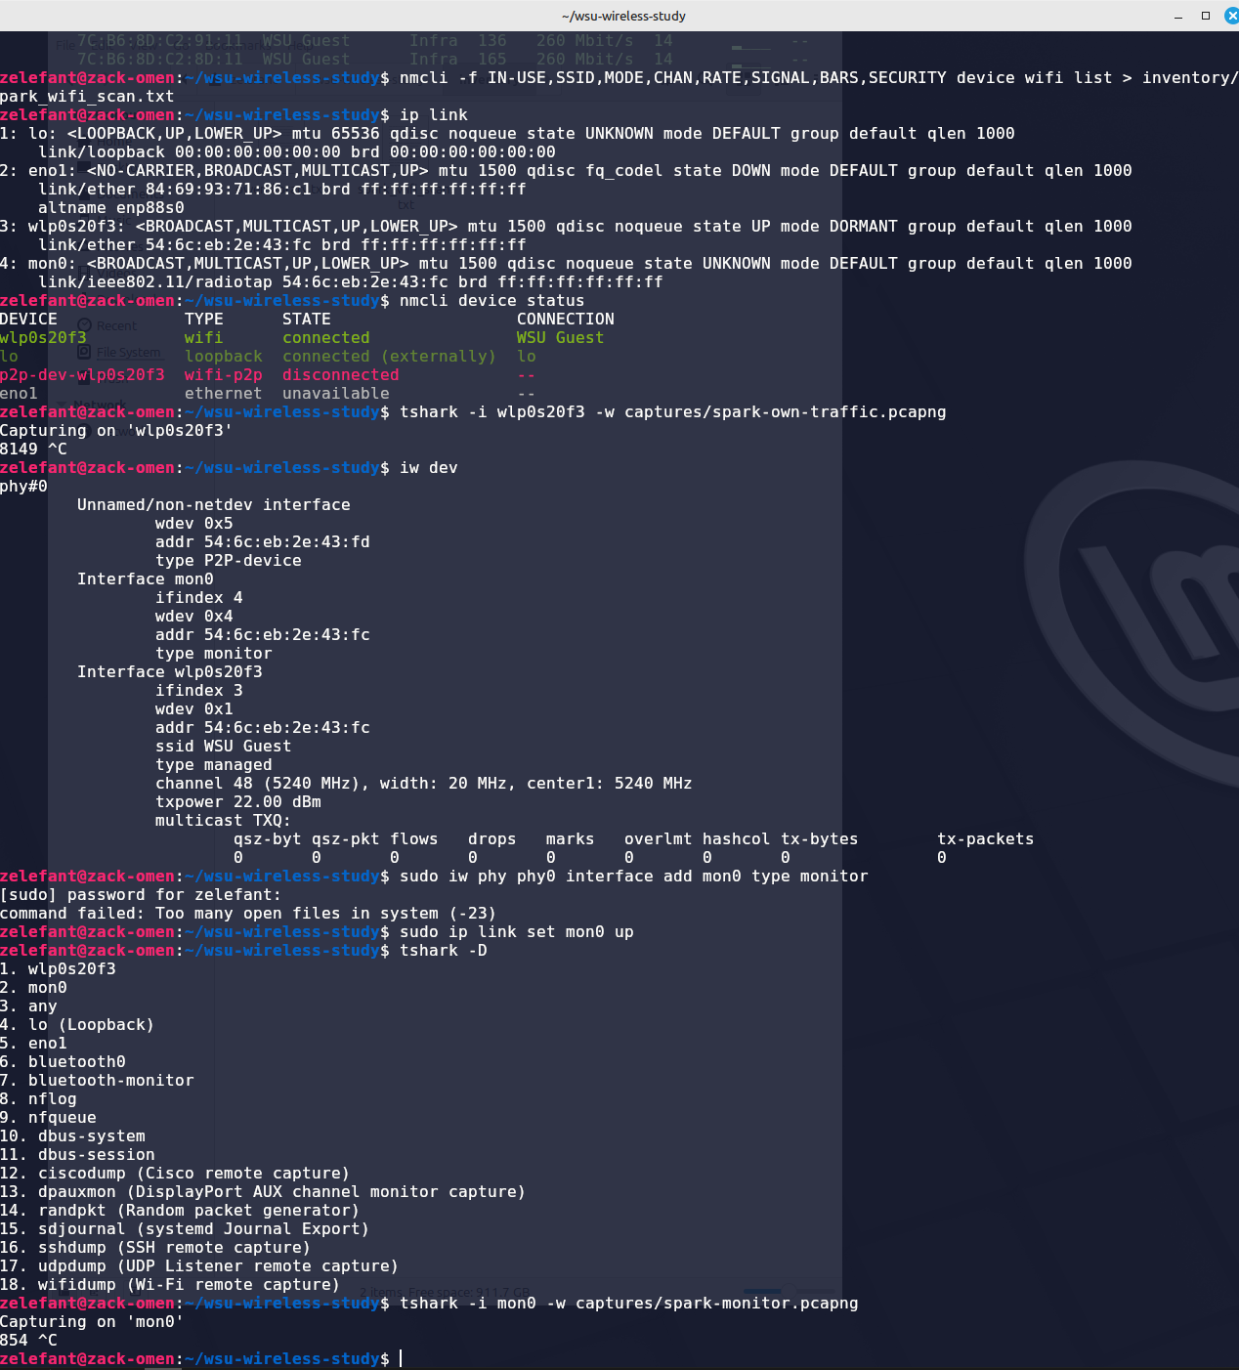
Live packet capture

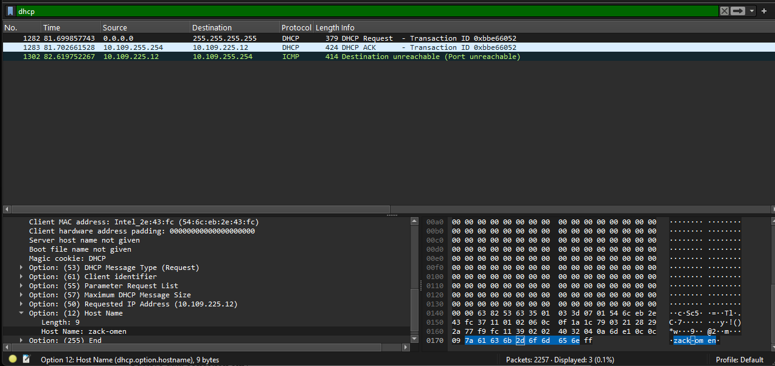DHCP identity exposure

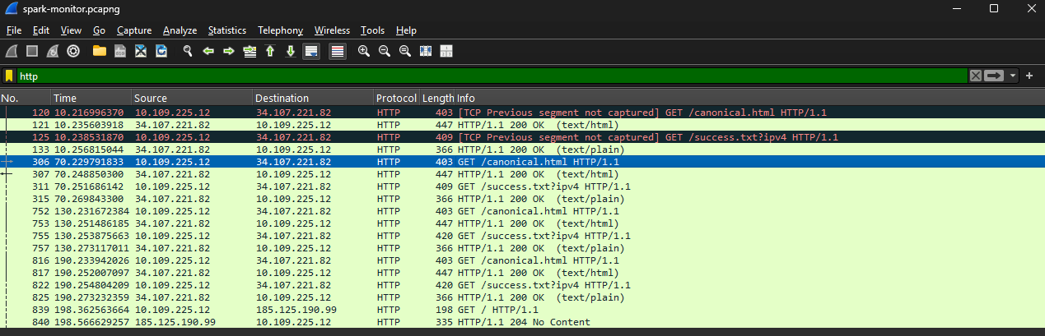
SPARK captive portal use exposure (HTTP)

